1. **Purpose**

To ensure that crystal product trucks are loaded properly and corresponding paperwork is filled out correctly according to company and regulatory requirements.

All finished crystal product is staged in the Lower warehouses located adjacent to the packaging area. Finished crystal product is staged in the warehouses as full loads for ease of tracking and loading. The loading dock is located adjacent to the Lower Warehouse. Giles can only load one truck at a time. Numerous Drivers can be staged in the parking area on Miller Street to simplify loading and street congestion.

1. **Scope**

This procedure needs to be performed for each crystal product truck loaded. This procedure applies to all crystal product trucks loaded from the Manufacturing facility.

1. **Responsibility**

All Manufacturing Warehouse Operators, Lead Operators and Salt Operators are responsible for this procedure.

Production Coordinator, Lead Customer Service Representative and Inventory specialist work together with the Manufacturing Warehouse Operator in arranging Load times, shipments and transfers.

1. **Safety Considerations**

* Safety shoes and safety glasses are required when working in the plant.
* Safety Belt is required when operating a Forklift.
* Safety is a condition of employment. Employees are not authorized to work in an unsafe manner and are prohibited from harming the environment of the facility or community.

1. **Materials/Equipment**

* Forklift
* Pick Slip/Bill Of Lading
* Seal
* Camera

1. **Procedure**
2. When a driver shows up for a load he is to go to the staging area located on Miller Street and call the plant. First available employee should answer the phone, and ask the driver for his pick-up number. Operator should reference the pick-up number to the customer order log. If a matching number is found proceed to item number 2 of this procedure. If there is no matching number, first ask the driver which street address he is picking up at, he could have called the wrong facility. If he called the correct facility, the driver must call his dispatcher and get a correct number.
3. Checking in by Appointment Times:
   1. Driver is early: Clock in and load as soon as possible but not after designated time
   2. Driver is on time: Clock in and load immediately
   3. Driver is late: Clock in and load when dock and yard is free from other appointment times.
4. Find the corresponding Pick List that matches the pick-up number out of the Pick List box and use the "Truck Loading Time" stamp to clock the driver in beside "Truck Arrived".
5. Driver must initial beside pick up number, clock in time, delivery location and weight of the order.
6. Locate the bin number beside the order on the customer order log, if no bin number is indicated, find a load completely matching order description in the warehouse. The loader should carefully read the order information both on the Pick Slip and the SCR in order to insure the correct product is loaded. It is the loader's responsibility to make sure the Special Customer Requirement (SCR) code is followed. The SCR number is located on the Pick slip and the COL.
7. As the driver is backing into the dock, it is good practice to stage the load. Begin taking the pallets from their bin and place them in an orderly manner near the loading dock for easy and quick loading and scan the product before loading.
8. Dock door is to remain closed until the trailer is docked correctly. Before loading, trailer is to be inspected. If trailer has noticeable amount of dirt, glass, scrap, trash or any residual from a wet or dry spill it cannot be loaded. Driver should be instructed to leave and come back with a clean trailer.
   1. Note dispute on Pick List for future reference.
   2. NO Trash of any type from a truck or trailer is to be disposed of within the Giles facility.
9. On the "Truck Loading Time" stamp, use the time clock to clock the driver in beside "Start".
10. Trucks are to be loaded according to the loading chart on page 9 of this procedure. If a driver would like to be loaded a different way it can be done but it is the driver's responsibility from that point forward. The driver is to be informed that if load is returned due to weight being over on axles, we do not take responsibility and will not unload once it has left Giles premises. Once you inform the driver of this, write a note on the pick slip stating that the driver changed the configuration and have driver sign it.
11. If the truck is not present during loading, jack stands much be placed under the trailer while loading.
12. While loading the truck, fill out the second page of the Pick List with checking each pallet for SCR Code compliance, hardness, print quality and leaking or torn bags etc… DO NOT LOAD if items are unacceptable.
13. Fill out a corresponding Certificate of Analyses (C of A) to be sent with the load.
14. After the truck is loaded, on the Pick List the loader signs and dates pallet check and clocks the driver out using the time clock beside the "Finish" section of the "Truck Loading Time" stamp. Both the Loader and the Driver must initial loading times stating when the truck arrived and when it was finished loading.
15. On the BOL the loader writes down Trailer number in vehicle number slot. The Lot number and the Seal number are to be written in the center section. The loader should then sign, date and put the time loading and paper work was completed in the designated area at the bottom. Have the driver sign and date in designated area.
16. A picture is then taken of the completed BOL and the loaded trailer.
17. Keep the top copy of the completed BOL for the office. Give the driver the second copy. Fold the third copy of the BOL with a Certificate of Analysis and any other customer required paper work. Put third copy and all other paper work in a shipping pouch, peel off the paper revealing the self-adhesive back and attach to the last pallet on the load.
18. Have the driver pull up 10 to15 feet in the dock and close his doors then physically put the seal on the truck after the driver closes the trailer doors.
19. Sign off the load on customer order log and place finished paper work in the BOL box ready for office pick up.

CRYSTAL LOADING REFERENCE SUMMERY

1. Get pick up number from the driver
   1. If no matching number, driver must call their dispatcher
   2. GILES **DOES NOT** LOAD WITHOUT A PICK UP NUMBER
2. Match number from the Driver with the load on the COL and Pick List.
   1. Driver must initial Pick up number and load weight before being clocked in.
3. Clock Driver in on the top page of the Pick List.
   1. If Early – wait till next opportunity
   2. If On time – Load immediately
   3. If Late – Load next available dock opening.
4. Check Pick List and Customer Order Log and Special Customer Requirements before loading.
5. Check **EACH AND EVERY** pallet for;
   1. SCR compliance, Wrap not torn, Pallet in good condition. No torn or leaking bags, Print on pallet clear ( both from printer and operator ) and Bags feel soft ( not crunchy or hard )
6. Loading Dock door **MUST REMAIN CLOSED** until trailer is docked correctly and ready to load
7. Inspect empty trailer for dirt, trash and structural integrity.
   1. Standing at the entrance of the trailer, take one photo of empty trailer
8. Use Trailer Stands if Tractor will not be under the Trailer during loading
9. Load Truck according to Giles policy - loading chart
   1. Contact Plant Manager, Production Coordinator or CSR before adjusting any load amount.
   2. With a single line mark though any corrections on all paper work
   3. Legible write in the new amount and weight to be loaded, and initial beside each.
   4. On the top sheet of pick slip write down the reason for shorting the load.
10. Fill out the second page of the Pick Sheet with proper information ( while loading )
11. Loader must sign off on “checking load conditions box” on the Pick Slip
12. Standing at the entrance of the trailer, take one photo of loaded trailer
13. Get a matching Certificate of Analysis for each lot number in the load.
14. Put Trailer number, Seal number and Lot Number on BOL
15. Clock driver out on the Pick Slip - Have driver initial times.
16. Take one picture of completed Pick Slip to go with the 2 pictures taken of the trailer
17. Loading dock door **MUST BE CLOSED** before trailer is pulled from dock
18. Loader and Truck Driver Signs BOL with Date and 24 hour time.
19. Completed Loading paperwork
    1. Giles gets completed pick list and one completed BOL
    2. Driver gets one copy of completed BOL.
    3. Fold third copy and place in a shipping pouch with all other customer related papers and stick to shrink wrap on the last pallet of the load in the truck.
20. Put seal on Truck – Loader must be present during seal application
21. Sign load off on shipping board and place paper work in "shipped box"

PICK SLIP

The Pick Sheet slip is the top sheet of a Bill of Lading or BOL. The Pick Slip is generated by the Customer Service Department when a Customer places and order. This is a quick reference of the BOL and customer order, this is information telling the loader what material and what amount the customer has ordered.

1. Get Pick up number from driver, compare number to Loading Board. Then find the corresponding BOL and Pick sheet.
2. Have Driver initial beside the Pick Up number on the pick slip.
3. Clock Driver in when they arrive and before you start loading and when finished
4. Check Product code and Amount needed.
5. Check off what location you are shipping the product from.
6. Check the condition of pallets, bags, print, hardness and SCR number before loading product. Sign off stating you have checked everything and it is acceptable.
7. SCR code is the Special Customer Requirements for the customer.

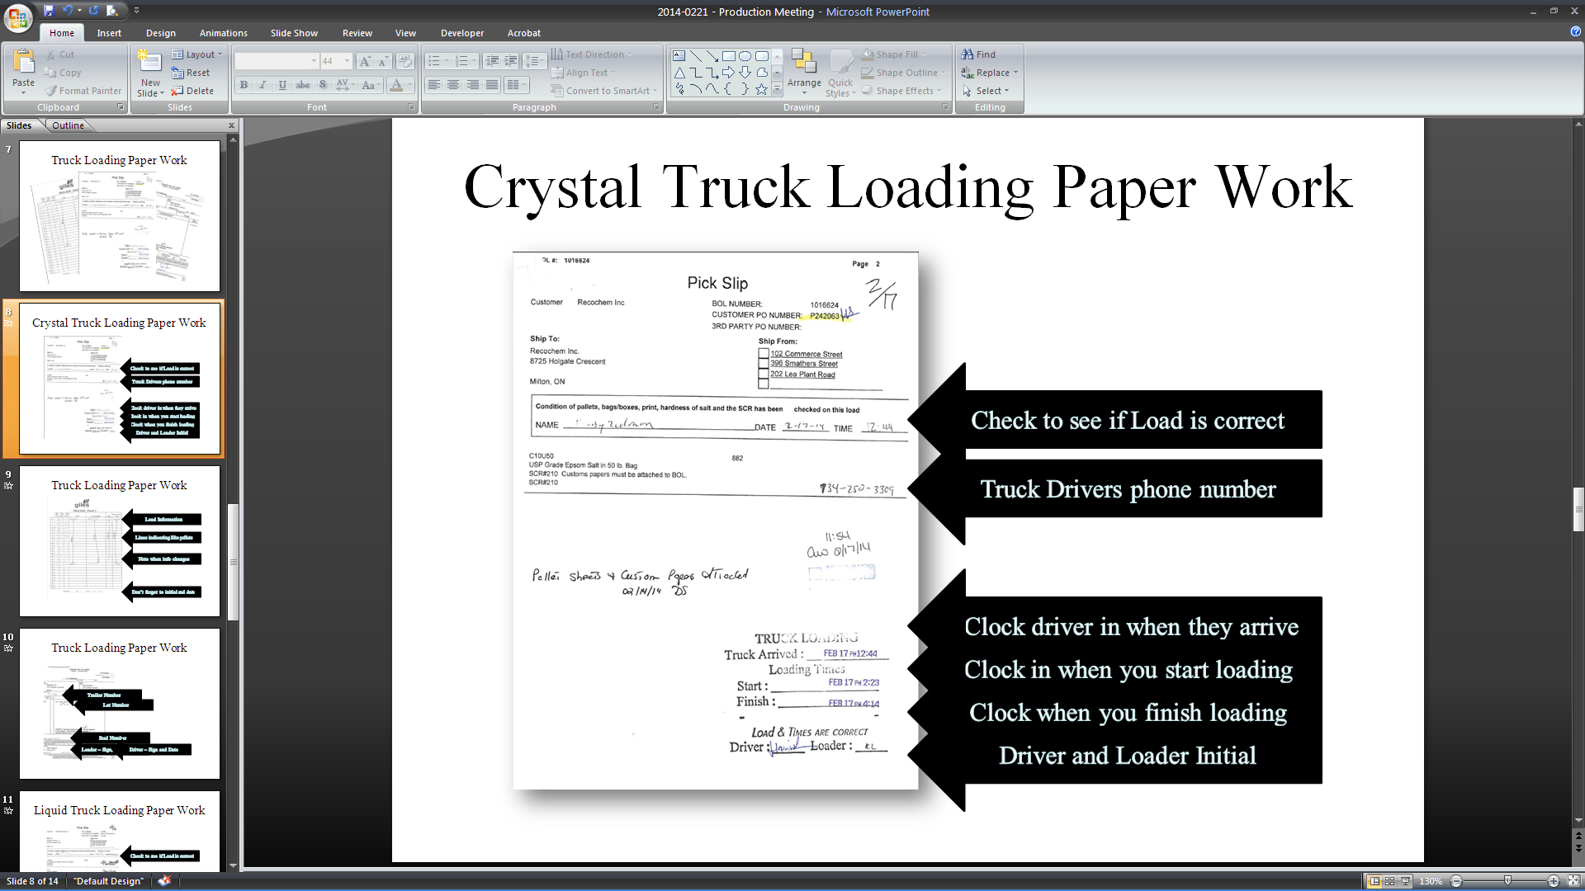

PICK SHEET PAGE 2

The Second page of the Pick Sheet is a check list for Truck Loading

This is also key information for the Customer Service and Quality Control Departments.

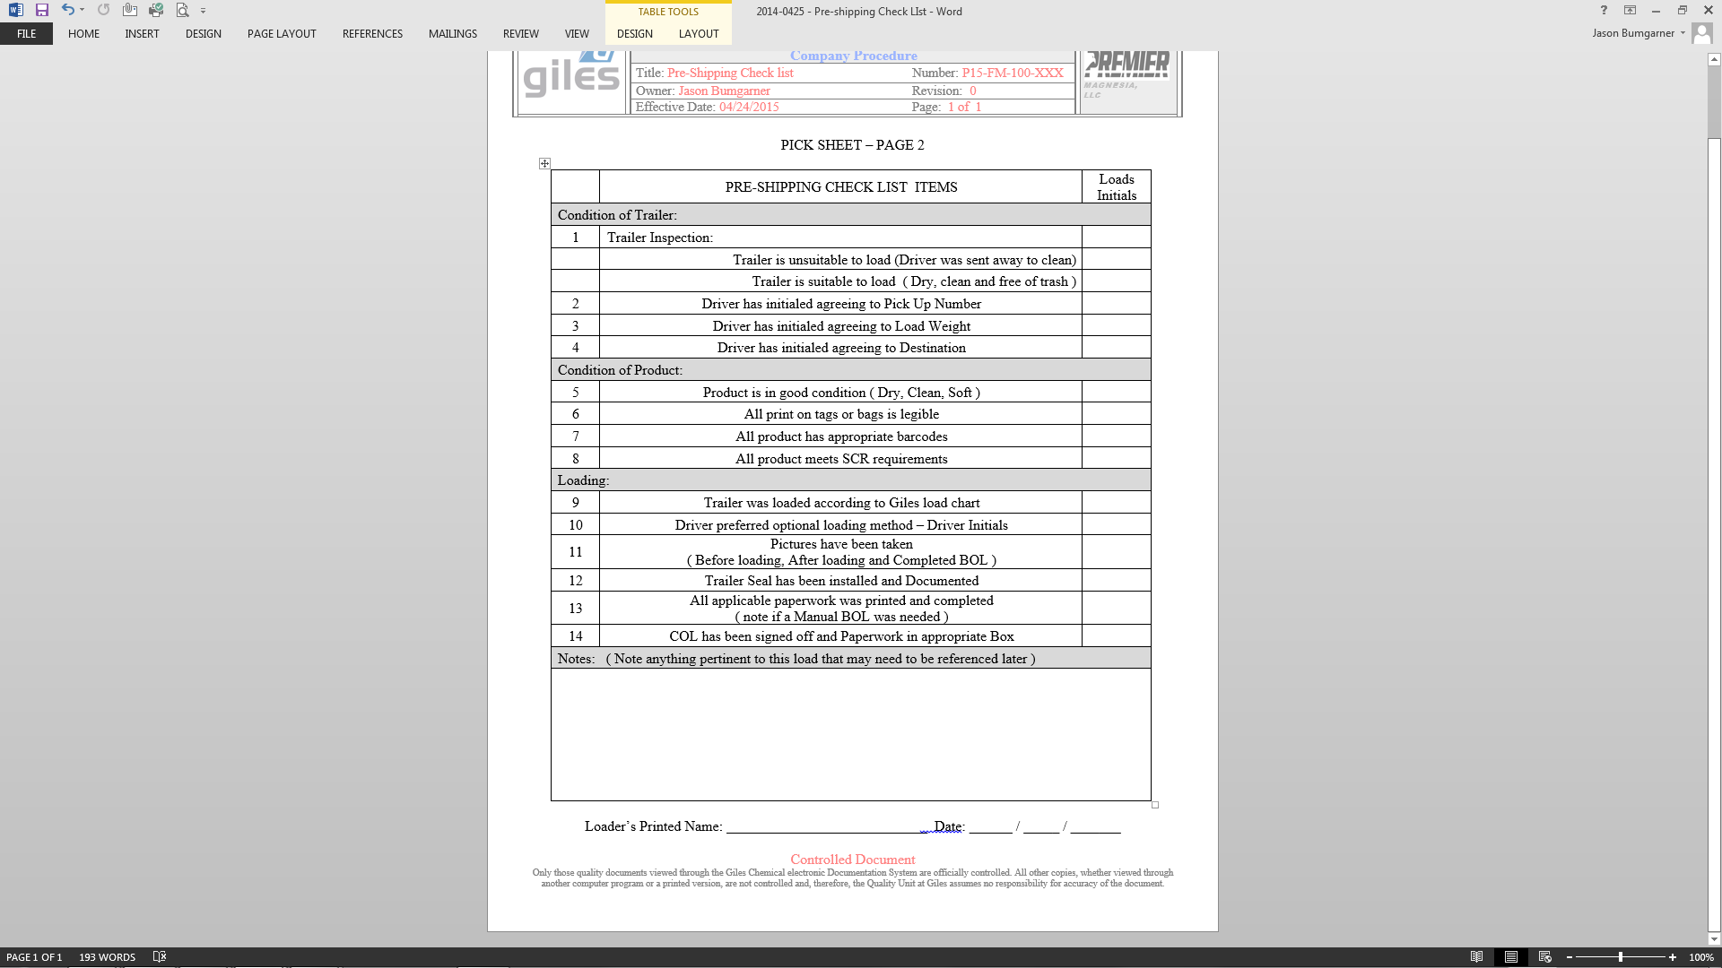

Any incident with the load should be noted here

If Trailer is not clean it must be sent away to be cleaned

STRAIGHT BILL OF LADING

The Bill of Lading is generated by the Customer Service Department when a Customer places and order. Just like the Pick sheet, this is key information telling the loader what material and what amount the customer has ordered as well as ship to location. There are three copies of the bill of lading, one for the office, one for the driver and the last one to be used as a packing slip and placed on the last pallet.

1. When you have completed load, Sign BOL with Date and 24:00 hour time.
2. Disperse the 3 copies of completed BOL
   1. Keep top copy
   2. Driver gets 2nd Copy
   3. Take last copy, fold and place inside a packing pouch and stick to last pallet.
3. Before Loading, check BOL for amount and product description.
4. Double check Pick Up number and Shipping Location.
5. Loader fills in
   1. Vehicle Number
   2. Lot Number
   3. Seal Number

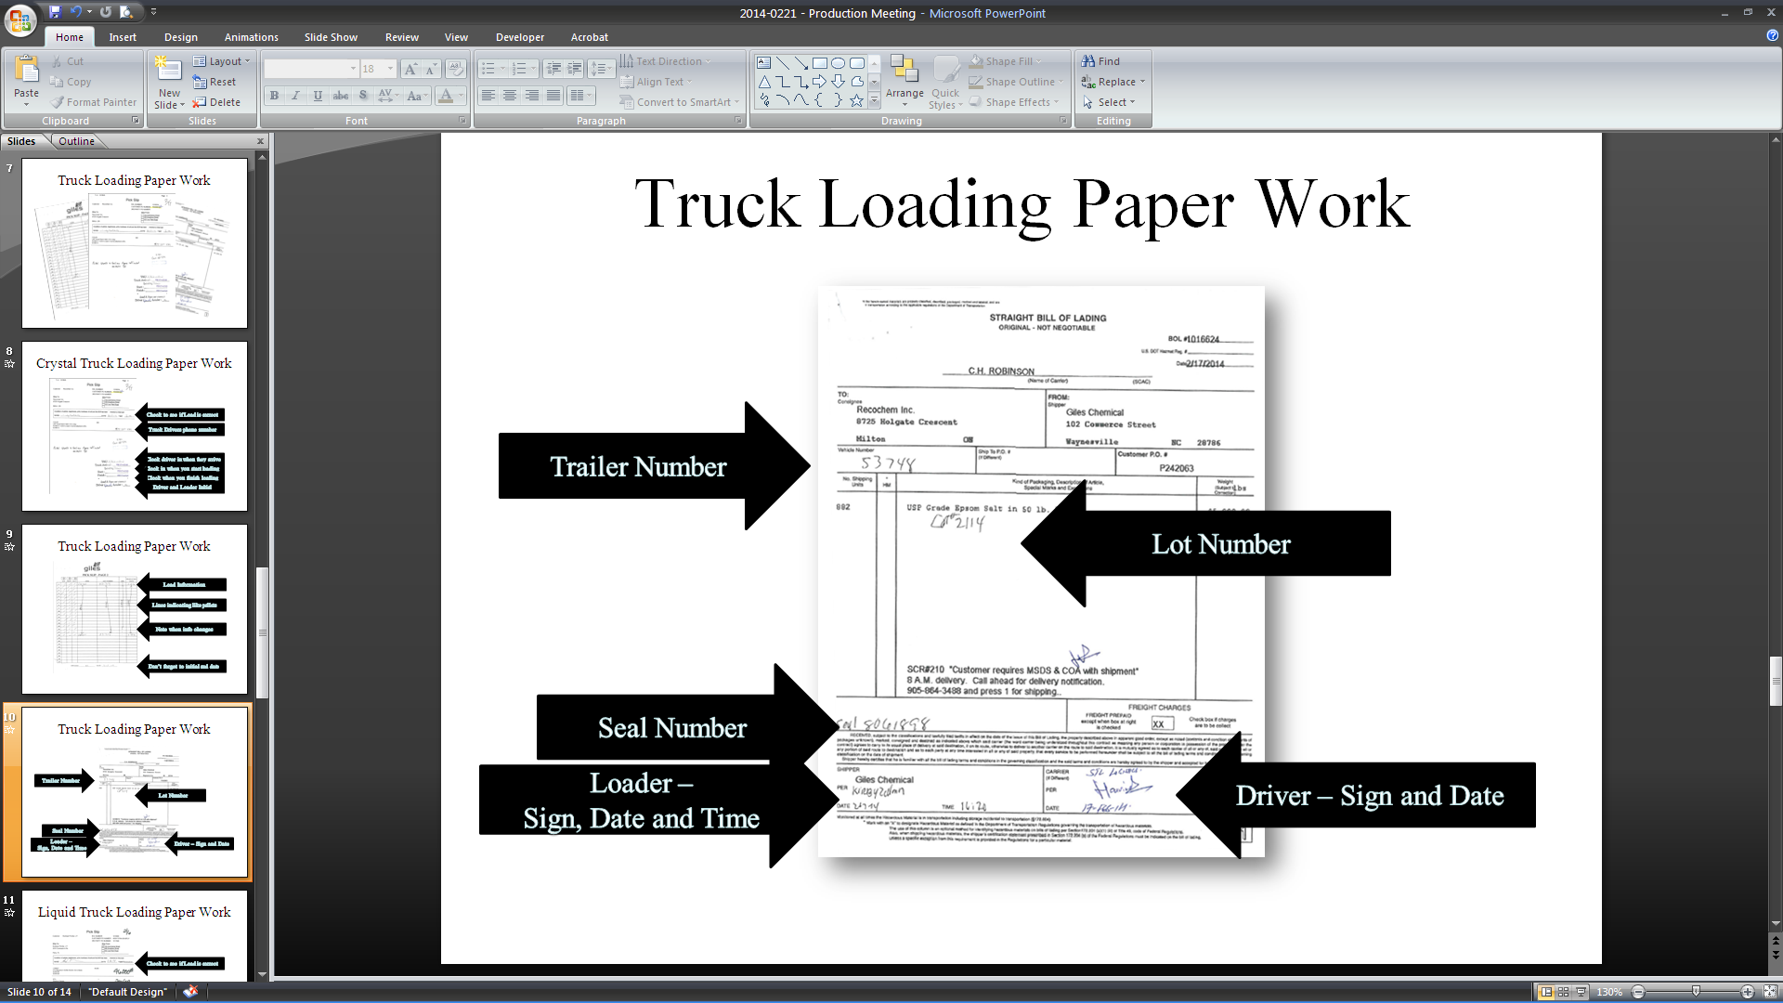

CHANGING A LOAD

1. If for any reason, something must be changed on a load, you must first call the Plant Manager or designated personnel for approval.
2. With a single line mark through the original amount on the 1st page of the pick slip. Write in the corrected amount. Legible explain the reason for changing the load.
3. With a single line mark through the original amount and weight on all three copies of the BOL. Write in the corrected amounts and initial.

STRAIGHT BILL OF LADING

ORIGNAL - NOT NEGOTIABLE

BOL # ________________

US dot Hazmet Reg # ________________________

DATE ________________

_________________Name of Company____________________

( name of Carrier )

|  |  |  |  |  |  |  |  |
| --- | --- | --- | --- | --- | --- | --- | --- |
| TO:  Name of Customer  Address  City, State | | | FROM:  Giles Chemical Corporation  102 Commerce Street  Waynesville, NC 28786 | | | | |
| Vehicle Number  6812 | | Ship To PO  1005698 | | | | Customer PO  144325695 | |
| No. Shipping  Units | HM | | Kind of Packaging, Description of Article | | | | Weight  lbs |
| 882  833 |  | | Tech Grade Epsom Salt in 50 lb. Bags | | | | 45,000  42,500  DM |
|  | | | | | FREIGHT CHARGES | | |
| ~~~~~~~~~~~~~~~~~~~~~~~~~~~~~~~~~~~~~~~~~~~~~~~~~~~~~~~~~~~~ | | | | | | | |
| Shipper  Giles Chemical Corporation  Per Doug Myer  Date 04/06/06 Time 16:25 | | | | Carrier  Per Zac Guy  Date 04/06/06 | | | |

Pick Slip

Customer - Customer name BOL NUMBER : ~~~~~~~~~~~~~~~

CUSTOMER PO NUMBER ~~~~~~~

3RD PARTY PO NUMBER ~~~~~~~

Ship To: Ship From

Customer Name and 🗌 102 Commerce Street

Ship to address 🗌 396 Smathers Street

🗌 202 Lea Plant Road

State 🗌 _________________

**Condition of pallets, bags/boxes, print hardness or salt and the SCR has been checked on this load**

NAME ____________________________ DATE ____________ TIME ____________

T-50 882

Tech Grade Epsom Salt in 50lb bags 833 - DM

**Trailer Number**

Driver refused to take full load - to heavy!!

DM

**Single strike though and initial with correction.**

**Single strike though and initial with correction and explanation.**

***You must have an explanation on pick slip***

WAREHOUSE CAMERA and LOADING PICTURES

Examples of the 3 pictures that are to be taken of every load shipped

(Repack *shipments may be excluded*)

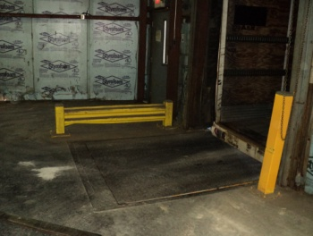

Stand here when taking pictures of trailer

|  |  |
| --- | --- |
| empty truck  #1 – before it is loaded  loaded truck  #2 – After it is loaded | BOL IIII  #3 – completed BOL  that goes with the load |

Giles Loading Configurations

Anything loaded other than pallet configuration listed below is Drivers responsibility

*(Drivers are to sign pick slip stating they want a different configuration than what is listed below)*

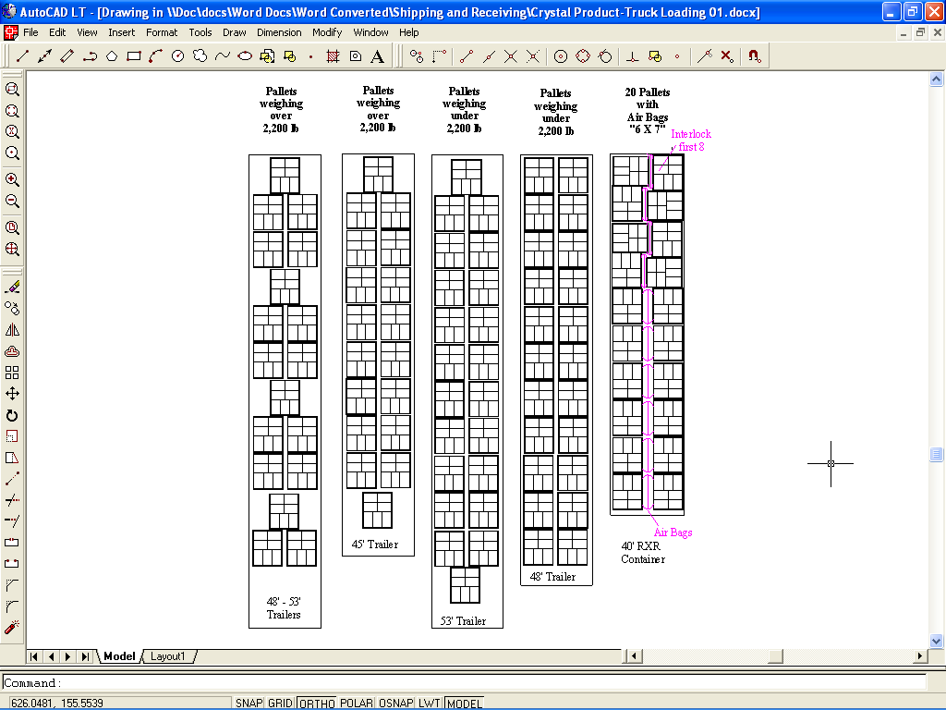

1. **Reference Documents**

N/A

1. **Change Information**

General updates throughout procedure to clarify instructions on completing paperwork properly.